Question #1: Two pulses traveling in the same uniform medium approach each other, as shown in the diagram below.
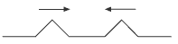
Which diagram best represents the superposition of the two pulses?
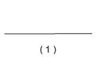 | 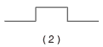 | 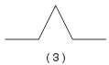 | 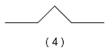

Question #2: The diagram below represents two pulses approaching each other.
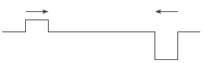
Which diagram best represents the resultant pulse at the instant the pulses are passing through each other?
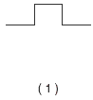 | 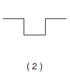 | 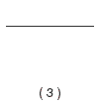 | 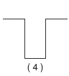

Question #3:
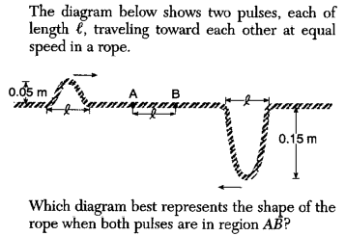
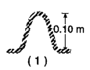 | 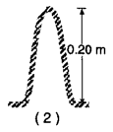 | 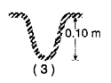 | 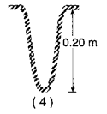

Question #4:
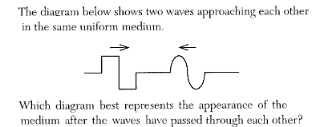
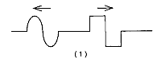 | 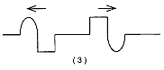
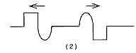 | 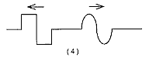
Question #5: The diagram below shows two pulses traveling toward each other in a uniform medium.
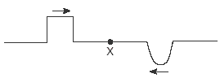
Which diagram best represents the medium when the pulses meet at point X?
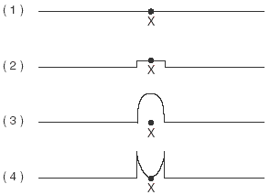
Question #6: The diagram below shows two pulses, A and B, approaching each other in a uniform medium.
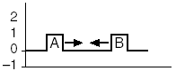
Which diagram best represents the superposition of the two pulses?
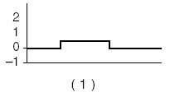 | 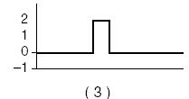
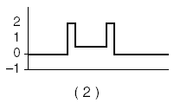 | 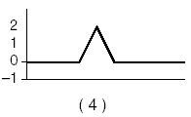
Question #7: Two pulses, A and B, travel toward each other along the same rope, as shown below.
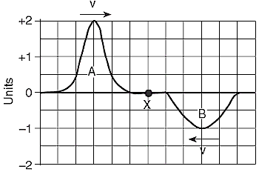
When the centers of the two pulses meet point X, the amplitude at the center of the resultant pulse will be
+1 unit | +2 units | 0 units | -1 units
Question #8: The diagram below shows two pulses of equal amplitude, A, approaching point P along a uniform string.
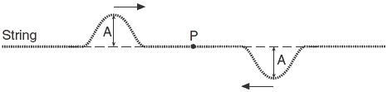
When the two pulses meet at P, the vertical displacement of the string at P will be
A | 2A | 0 | 0.5 A

